Debugging Exercise Report
Name: Anthony Farah
Date: May 20, 2026
Debugging Exercise
At the outset of this debugging exercise, I ran the original Debugging_Exercise.py file in PyCharm to observe the program’s behavior before making any modifications. Initially, the program appeared to function correctly, successfully calculating the discount and final price for the Laptop and Smartphone products. However, when processing the Tablet product, the code generated an error and terminated execution. To investigate the issue in greater detail, I utilized PyCharm’s debugging tools to step through the program line by line. I set a breakpoint within the main() function’s loop where the discount was calculated and monitored the variables in the debugger as each product was processed. This approach clarified which values were being passed into the functions.
The primary issue I identified was that the price value for the Tablet product was stored as a string ("500") rather than a numeric value. This became evident in the PyCharm Variables panel, where the Tablet’s product dictionary displayed 'price': '500'. As a result, the program failed when the calculate_discount() function attempted to multiply the price by the discount_rate. Since Python cannot multiply a string by a float, a TypeError was raised. The debugger confirmed where the program halted and revealed the incorrect data type used in the calculation, making the root cause clear.
After identifying the bug, I decided that a more robust solution was needed beyond simply changing "500" to 500. To enhance the program’s resilience to incorrect values, I implemented a validate_price() function that converts the price to a float and ensures it is non-negative. This enables string values such as "500" to be converted before calculations. To further secure the process, I added a validate_discount_rate() function to check that the discount rate is numeric and within 0 and 1. These steps protect against invalid data and increase reliability. To prevent unexpected terminations, I wrapped each product’s processing in a try/except block so that invalid data triggers a clear error message rather than causing the program to stop.
To further improve the code, I reorganized it into smaller, purpose-specific functions. For example, different functions now handle price and discount rate validation, discount calculation, discount application, and output display. This modular approach improves readability and fulfills the instructor’s requirement for functional organization. I also provided explanatory comments above code sections, enhancing understanding for both the programmer and the instructor.
After implementing these changes, I tested the revised code with the original product list and invalid values, such as non-numeric prices, negative prices, and out-of-range discount rates. In each scenario, the program displayed a clear error message and continued processing valid products. This confirmed that the updated code manages incorrect variable values more effectively than the original version.
Overall, this exercise highlighted the need to validate input data rather than assume values are correct. While the original program’s logic worked for valid input, it lacked error-checking. By using PyCharm’s debugger, I quickly pinpointed the issue. The updated code now validates input, handles errors gracefully, and continues processing even when one product entry fails, making the program more reliable and robust.
Testing Section
I evaluated the revised program with the original product list and various invalid values. In all cases, the program displayed a clear error message for problematic input and continued processing valid products. This demonstrates that the update resolves the original bug and enables robust error handling.
Summary and Conclusion
This debugging exercise reinforced the importance of checking variable types and validating input before calculations. PyCharm’s debugging tools showed that a string was used where a number was needed. I responded by implementing input validation, improving error handling, and splitting the code into distinct functions. Testing confirmed that the program can now manage various inputs more reliably, making it more readable and robust.

Screenshot of Debugging Process
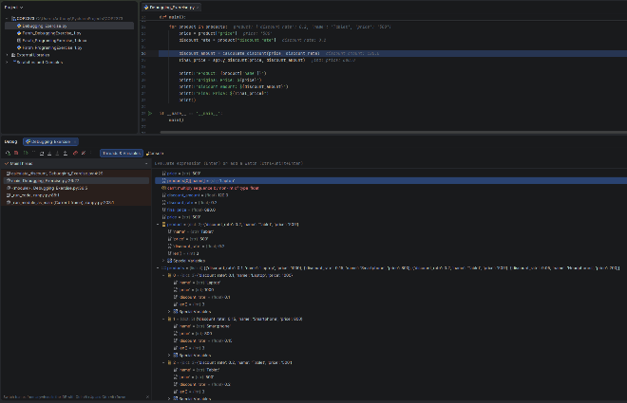
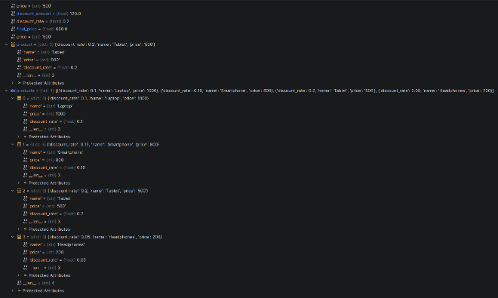
Output from the Corrected Program
